SUNCLIFF EDUCATIONAL FOUNDATION

`

6892 Lakeshore Road
Derby, NY 14047

Public Notice: Seeking Teachers and Instructors For Summer/Year-Round Programs
We are looking for individuals who inspire and make a difference — champions eager to
share their craftsmanship, artistic pursuits, career expertise, skills, and talents.

POSSIBLE SESSION IDEAS

Painting
Music
Sculpture
Photography
Dance
Acting
Career Artisan
Writing/Journaling
Linguistics
Oration/Debate
Legal Writing
Professional Development
Conservation
Landscaping
Yarn Crafts
Quilting
Yoga/Meditation
Tai Chi
Wellness
“Better Teaching”
Your suggestions!

We are developing an influential foundation of knowledge-sharing through our
inspirational network of people and our venue here at Suncliff.
If you are interested in a teaching position in any of the education programs above, or have an exciting
program of your own to offer, we at Suncliff would like to discuss implementing them with you.
Students can span a range of ages, from high schoolers to adults.
Session scheduling is flexible and can be tailored to fit your preferred days and times.
Please send us your name and contact info (email, phone), description of the theme/program you’re interested in, a timeframe to schedule your program, student expectations, staff/faculty needs, and any education materials required.

EMAIL US AT: suncliffeducationalfoundation@gmail.com
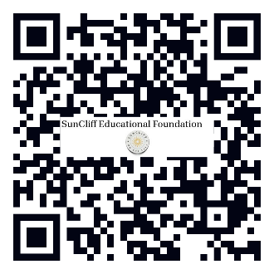
WEBSITE: http://suncliffeducationalfoundation.org/
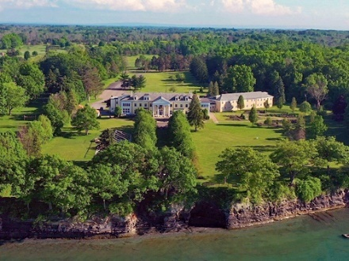
OR TEXT/CALL US AT: 1.716.255.9667

